Title of the paper (times new roman, 14 point, 1.5 lines spacing auto)
Theme : _________________________
Author 1 name* , Affiliation, Email id
Author 2 name , Affiliation, Email id
Author 3 name, Affiliation, Email id
(Mark a * against the name of corresponding author)
Abstract: Abstract should clearly state the purpose, methodology, findings, originality, and value. It should be maximum of 350 words. Strictly restrict to this template. Type abstract in MS Word (times New Roman, Font size 11 pts, Italics, 1.5 line spacing with auto spacing before and after). Full papers must be submitted through the online submission system as per the guidelines mentioned in the further sections. Authors must ensure that the submitted paper is their original work, which has not been previously published. The conference organizing committee shall scrutinize all papers for plagiarism before forwarding it for technical review. The conference organizing committee holds the right to send the manuscript back to the authors for revisions if plagiarism is found. By submitting a full paper authors agree that if their paper is selected, at least one of the authors will attend the conference. Once the full paper is accepted after the double-blind peer review process, authors will be asked to submit the final version of the manuscript. The final reviewed paper with all comments duly incorporated will be submitted before the conference. Select quality papers will be compiled in proceedings to be published with Scopus (based upon the approval).
Keywords: 3-5 keywords separated by a semi-colon
- Introduction
All full-length paper submissions must be in English, also the table and figure texts. All manuscripts must be formatted as per this template. The editorial of the international conference on Urban Transformation (ICUT- 2023) cannot undertake formatting for you.
For submission, TWO SEPARATE files should be uploaded. The first file should contain the manuscript with author details, this file should be named as ‘ICUT2023-shortened title-subm.doc’. For example, if the paper is titled ‘Analysing the urban heat island effect: Case of Pune’, the file name could be ‘ICUT2023-urban heat island-subm.doc’.
The second file should be a manuscript without author details and this file should be named as ‘ICUT2023-shortened title-rev.doc’. This manuscript should exclude the part of author’s name and details given in this template. This manuscript will then be subjected to blind review. Upon selection of the paper, for this conference the corresponding author will be intimated by email. The presentations for the conference can then be prepared.
Authors are encouraged to used APA style formatting. The page limit for full papers is between 10 - 12 A4 pages (1” page margins all sides) which would normally include 3000-5000 words including references, figures, tables etc. Use Times New Roman font with 12 pt size and 1.5 lines spacing with auto spacing above and below. Section heading should be Times New Roman font with 12 pt size and bold.
Introduction section normally states the background, literature review, motivation, purpose, scope and limitations of the study.
- Copyright
The author is legally responsible for complying with the copyright laws and the laws of privacy. If an author uses any work by another person in any way, good scholarly and publishing practice requires that proper credit is given, citing the source of the work borrowed. When works have more than one source, each must be cited. A photograph, an image, or a table must be accompanied by a credit line naming the owner.
One’s own work, if it has been previously published elsewhere, must also be credited.Giving credit for all borrowings does not relieve an author from the need to obtain permissions. The author is legally required to obtain permission to reproduce, photograph, translate, or paraphrase any work or part of a work that is protected by copyright.NOCPDM-2022 cannot be held responsible for any shortcomings of non-adherence to these.
- Methodology
This section of the research paper provides a description of how the research is done. It clearly mentions the methods, tools, and techniques which were used to reach the objectives of the research. Explain and justify the methods, tools, and techniques of the data collection, and procedure of the analysis.
- Results and Discussions
Present the findings of the research in this section in an orderly fashion.
  - Subsection 1
The results can be divided in sections and subsections depending upon the individual research requirements. The headings or subheadings can be planned as per the research methodology or specific patterns arising out of each research.
  - Subsection 2
Any new trend or something unexpected can be highlighted in the results and discussions section. It can either come as a continuous body or under separate sections and sub-sections. Discussion can be about a new identified trend or the understanding of the results.
- Conclusion
In the conclusion section, summaries the findings and highlight the significance of the research carried out. Anything new at this point shall not be added.
    - Figures & Tables
All the figures must be of high quality resolution and should be in the standard format such as . png. Figures should be numbered sequentially throughout the manuscript. All the figures must have figure caption given below the figure and must be cited in the main text (Figure 1). Authors should provide the source of the figure if adopted from other sources. All figures shall be sequentially kept at the end of the document
Tables should be numbered sequentially throughout the manuscript. All the tables must have table title given above the table and must be cited in the main text (Table 1). Authors should provide the source of the table if adopted from other sources.
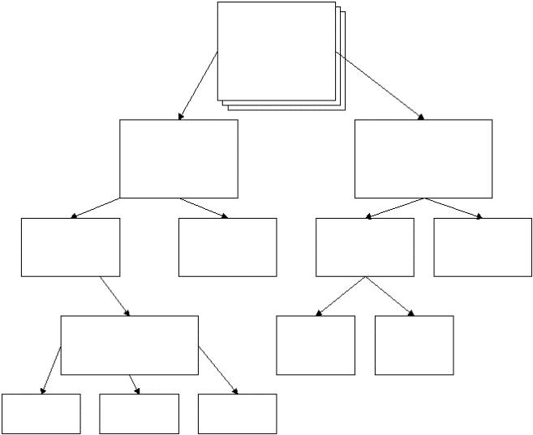
Figure 1 is the caption of a figure, it goes below the figure
Table 1 This is the caption of a table. It goes above the table.
Sample Name | Sample ID | Response 1 |  | Response 2 (%)
Sample 1 | 1097 | 16.50 |  | 72.00
Sample 2 | 1117 | 18.50 |  | 62.00
Sample 3 | 1103 | 17.00 |  | 61.00
    - Equations
Equations shall be numbered in parentheses at the right margin. You can also use MathType for more complex equations.
C² = x³y² + Ax² + 2Bxy (1)
Where:
C = A quantity in GJ; x = the number of variables; etc.
    - Citations and References
Alphabetically list all the reference materials that have been cited in the text (Teo et al., 1997). You can use the APA style of referencing and citation (Evans, 2003). APA is an 'author/date' system; therefore in-text reference for all formats (book, journal article, web document) consists of the author(s) surname and year of publication. The basics of an in-text reference in APA are including author or authors and year of publication in the round brackets e.g. (IPCC, 2001)
- References
Evans, G. W. (2003). The built environment and mental health. Journal of Urban Health, 80(4), 536–555. https://doi.org/10.1093/jurban/jtg063
IPCC. (2001). Climate Change 2001. Synthesis Report. IPCC Third Assessment Report (TAR). Ipcc, 409. http://www.ipcc.ch/ipccreports/tar/
Teo, T. S. H., Ang, J. S. K., & Pavri, F. N. (1997). The state of strategic IS planning practices in Singapore. Information & Management, 33(1), 13–23. https://doi.org/https://doi.org/10.1016/S0378-7206(97)00033-5
- Appendices

